- Battery installation method.
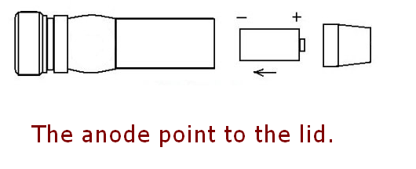
- The use of attention
Do not continuous light the laser over 120 seconds, we advice you turn off the laser every 60 seconds when the room temperature is too high. This is a high power handheld laser pointer, large heat productivity but do not have the heat radiating device, long time lighting is easily burnt out laser tube, will cause the laser point does not light or faint light..
- Security warning
- Do not look at the laser directly.
- Do not use laser irradiation of others.
- Do not use laser irradiation the objects which is easy to reflect light.
- Do not let a minor child touch laser pointer.

- Battery installation method.
- The use of attention
Do not continuous light the laser over 60s, we advice you turn off the laser every 30s when the room temperature is too high. This is a high power handheld laser pointer, large heat productivity but do not have the heat radiating device, long time lighting is easily burnt out laser tube, will cause the laser point does not light or faint light.
- Security warning
- Do not look at the laser directly.
- Do not use laser irradiation of others.
- Do not use laser irradiation the objects which is easy to reflect light.
- Do not let a minor child touch laser pointer.

